Headache in Children Guideline
Headaches are common in children (3% for ages 3-7 years) and even more so in adolescents (8%-23% for ages 11-15 years). Parents become concerned because they often assume that headaches are rare in childhood and therefore indicate a serious disease. Headaches caused by brain tumours however are very uncommon (0.3% of children with headaches have a brain tumour, and 0.03% of children with headaches and no red flags have a tumour).
Child presents with headache

Complete history, physical and neurological examination

No red flags
Red flags

Classify the headache (see appendix)

Emergency/Urgent Referral
- If acute headache with fever/coma -> Admit via the on-call team
- All other red flag headaches -> Discuss with Paediatric Consultant 1300-2100hrs on 07973742812
- For age related red flags visit www.headsmart.org.uk

Begin headache treatment

Keep an ongoing log of date, time, situation, treatment, response for headaches
Be aware of medication overuse headache*

Refer if headache type is unclassified or treatment fails

*More than 2 doses of analgesic use per week carry a risk of medication overuse headache

Red Flags – from headsmart – www.headsmart.org.uk
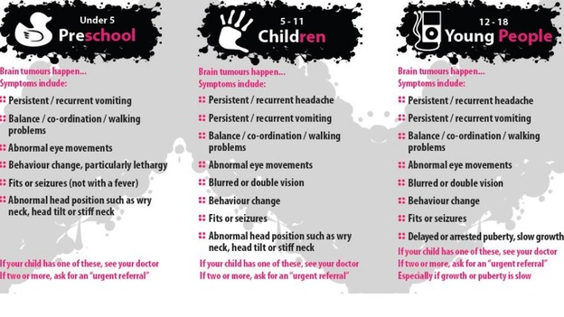
Headache Classification and Treatment: see link (will open appendix 1)
Investigations:
Headaches with no red flags do not need neuro-imaging.
Do not refer for/undertake a brain scan in primary headache for reassurance.
Primary Care Management:
- General advice
- Explore and address parental / patient concerns especially about brain tumours/meningitis. Explain why you think this is unlikely to be the cause of headache.
- Recognition that headache is a valid medical disorder that can have a significant impact on the child / young person, but that there is a good chance of improvement with time without preventative treatment.
- Warn about the risk of medication overuse headaches.
- Safety net – explaining red flags and when to seek review.

- Headache Hygiene
- Stay hydrated
- Adequate sleep
- Regular meals
- Recognize trigger foods - caffeine, cheddar cheese, chocolate, red meat, dairy products, vinegar, bacon, hotdogs, pepperoni, deli meats, smoked fish, sausages. Food with MSG=dry roasted nuts, Chinese food, soy sauce
- Recognize other triggers - over-exertion, stress, loud noise, intense emotion/anger, excitement, weather changes, sunlight, heat, strong odours, passive smoke, chemical fumes, medication, hormone changes & menstrual cycles
- Do some relaxation, such as yoga

- Specific treatments according to headache type - see link (will open appendix 1)

- Patient/parent resources
- Migraine Action, http://www.migraine.org.uk/young-people/migraine-in-youth/
- Medication Overuse Headache, Information for Families. Great Ormond Street Hospital – add PDF here
- Headache in Children, Information for families. Great Ormond Street Hospital-add PDF here

Medication Overuse Headache (MOH)
- A chronic headache caused by the overuse of analgesia
- Explanation of the problem is the key
- Managed by withdrawing the overused medication - withdrawal will result in either complete resolution of the headache (if MOH is the only cause of the headache) or return to the original headache type (if frequent medication had been used to treat this type)

References and contributors:
Headsmart – www.headsmart.org.uk
NICE Guidance on Headaches in over 12's: Diagnosis and Management (CG150), Updated 2015 https://www.nice.org.uk/guidance/cg150/chapter/Recommendations
North & East Devon Formulary and Referral Site, Children & Adolescents, Headache https://northeast.devonformularyguidance.nhs.uk/referral-guidance/eastern-locality/paediatrics/headache-in-
Dr Rebecca Harling, GP and RMS Lead for Paediatrics and Ophthalmology
Dr Shama Goyal, Consultant Paediatrician with Special Interest in Paediatric Oncology, Royal Cornwall Hospital.

Appendix 1
Headache types and treatment (adapted from NICE guidance 2015)
 | Tension-type headache | Migraine (with or without aura) |  | Short, severe headaches
Location | Bilateral | Unilateral or bilateral, usually frontal |  | Unilateral or bilateral, usually temporal
Quality | Constant / tightening | Throbbing or banging |  | Sharp, lightning-like
Intensity | Mild or moderate | Moderate or severe |  | Moderate or severe
Duration | 30 minutes – continuous | 1–72 hours |  | Idiopathic stabbing headache: 1-3 seconds  Cluster headache / related: longer but less than 3 hours
Other symptoms | None  Nausea may occur with chronic tension-type headache | Photophobia / phonophobia can be inferred by behaviour  Nausea, vomiting, pallor  Aura symptoms:  -are fully reversible  -develop over at least 5 minutes and last 5−60 minutes  -may include visual symptoms such as flickering lights, spots or lines and/or partial loss of vision; sensory symptoms such as pins and needles, speech disturbance, confusion |  | Idiopathic stabbing headache = none  Cluster headache = autonomic features (e.g. ptosis, midriasis, eye watering). These are very rare in childhood
Effect on activities | Rarely incapacitates patient | Usually incapacitating, and worsened by movement  Relieved by sleep |  | Restlessness or agitation
Frequency & Diagnosis | Less than 15 days per month = Episodic tension-type headache  More than 15 days per month for more than 3 months =  Chronic tension-type headache | Less than 15 days per month = Episodic migraine (with or without aura)  More than 15 days per month for more than 3 months = Chronic migraine (with or without aura) |  | Highly variable = Idiopathic stabbing headache  1 every other day to 8 per day, with remission > 1 month  = Cluster headache
Treatment | Tension Headaches | Migraine with/without aura | Short severe headaches
Acute | 1.Paracetamol/ibuprofen  2.Distraction/ relaxation  3.Encourage to stay at school | 1.Rest/sleep  2.Prompt ibuprofen  3.If nausea/vomiting – add in buccastem (licensed in children > 12yrs) and/or Ondansetron melts for younger children  4.Sumatriptan 10mg nasal spray (licensed in children > 12years)  5.If fails, check medication being used promptly and correctly | These are uncommon.  Seek specialist advice.
Lifestyle Modifications | Headache Hygiene | Headache Hygiene | Headache Hygiene
Preventative | For children > 12yrs consider acupuncture. This is not available via paediatrics. | - Explain no curative treatment  - If > 12yrs of age, consider propranolol or pizotifen  - Review the need for prophylaxis every 6 months  - If treatment fails-> refer.

Some headaches are 'unclassifiable', especially in young children who cannot describe their headaches. Even so, most unclassifiable headaches are primary in origin.
Tension-type and migraine headaches can occur concurrently in the same patient. If this is the case treat migraines as above and where tension-type headache develops alongside migraine, consider medication overuse.

